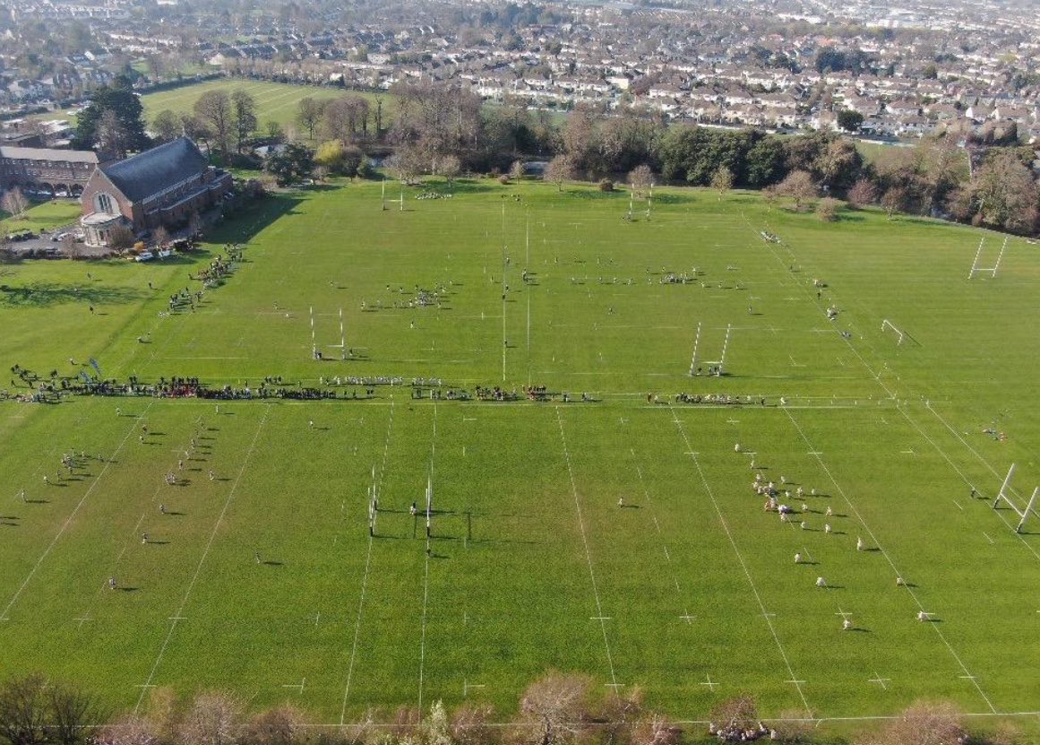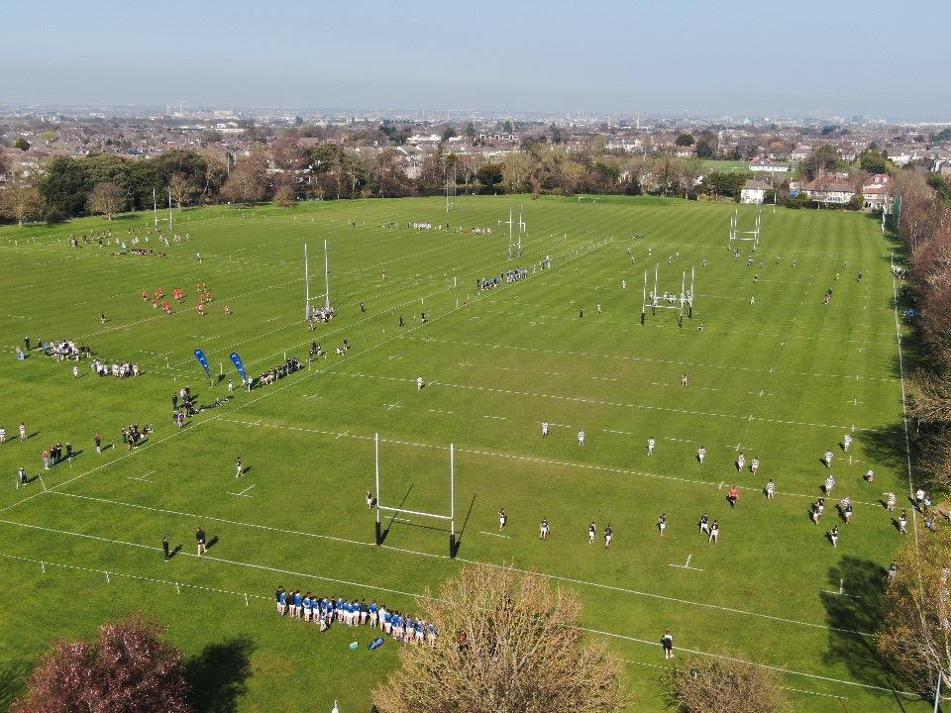

[Sidebars are great for calling out important points from your text or adding additional info for quick reference, such as a schedule.

They are typically placed on the left, right, top or bottom of the page. But you can easily drag them to any position you prefer.

When you’re ready to add your content, just click here and start typing.]

**Terenure College Full Fixture List 2024/25**

|  |  |  |  |  |  |  |  |
| --- | --- | --- | --- | --- | --- | --- | --- |
| SCT 1st & 2nd XV’s Fixture List 24/25 | | | | | | | |
| September | | | | **October** | | | |
| *Date* | *Opponent* | *Teams* | *Venue* | *Date* | *Opponent* | *Teams* | *Venue* |
| *Sat Aug 30th* |  |  |  | *Wed 2nd* |  |  |  |
| *Wed 4th* | **Gonzaga** | 1st /2nd | Away | *Sat 5th* | **Blackrock** | 1st /2nd | Home |
| *Sat 7th* |  |  |  | *Wed 9th* |  |  |  |
| *Wed 11th* |  |  |  | *Sat 12th* |  |  |  |
| *Sat 14th* |  |  |  | *Wed 16th* | **Campbell** | 1st /2nd | Away |
| *Wed 18th* |  |  |  | *Sat 19th* | ***Coll. Bristol [Eng]*** | 1st XV | Home |
| *Sat 21st* | **Belvedere** | 1st /2nd | Home | *Wed 23rd* | **St. Mary’s** | 2nd XV | Away |
| *Wed 25th* |  |  |  | *Fri 25th* | **St. Mary’s** | 1st XV | Away |
| *Sat 28th* | **RBAI** | 1st /2nd | Away | *Wed 30th* | *Oct Mid-Term* |  |  |
| November | | | | **December** | | | |
| *Sat 2nd* | **Connacht 18s** | 1ST XV | Home | *Wed 4th* |  |  |  |
| *Wed 6th* |  |  |  | *Thu 5th* | ***Paarl Boys [SA]*** | 1st /2nd | Home |
| *Sat 9th* | **Sullivan Upr.** | 1st /2nd | Home | *Wed 11th* |  |  |  |
| *Wed 13th* |  |  |  | *Fri 13th* | ***Clifton [Eng]*** | 1st XV | Away |
| *Fri 15th* | ***Cardinal Newman [ARG]*** | 1st - 3rd | Home | *Wed 18th* |  |  |  |
| *Wed 20th* |  |  |  | *Sat 21st* | *Xmas Holidays* |  |  |
| *Sat 23rd* | **St. Michael’s** | 1st /2nd | Home | *Wed 25th* | *Xmas Holidays* |  |  |
| *Wed 27th* |  |  |  | *Sat 28th* | **PBC Cork** | 1st /2nd | Away |
| *Sat 30th* | **CBC Cork** | 1st /2nd | Away |  |  |  |  |
| January | | | | **February** | | | |
| *Wed 1st* | *Xmas Holidays* |  |  | *Sat 1st* |  |  |  |
| *Sat 4th* |  |  |  | *Wed 5th* |  |  |  |
| *Wed 8th* |  |  |  | *Sat 8th* |  |  |  |
| *Sat 11th* | **Castleknock** | 1st XV | Home | *Wed 12th* |  |  |  |
| *Wed 15th* |  |  |  | *Sat 15th* | *Feb Mid-Term* |  |  |
| *Sat 18th* | **Crescent** | 1st XV | Away | *Wed 17th* | *Feb Mid-Term* |  |  |
| *Wed 22nd* |  |  |  | *Sat 22nd* | *Feb Mid-Term* |  |  |
| *Sat 25th* |  |  |  | *Wed 26th* |  |  |  |
| *Wed 29th* |  |  |  |  |  |  |  |
| March | | | | | | | |
| *Sat 1st* |  |  |  | *Wed 12th* |  |  |  |
| *Wed 5th* |  |  |  | *Sat 14th* |  |  |  |
| *Sat 7th* |  |  |  | *Wed 19th* |  |  |  |
| JCT 1st & 2nd XV’s Fixture List 24/25 | | | | | | | |
| September | | | | **October** | | | |
| *Date* | *Opponent* | *Teams* | *Venue* | *Date* | *Opponent* | *Teams* | *Venue* |
| *Sat Aug 30th* |  |  |  | *Wed 2nd* |  |  |  |
| *Wed 4th* |  |  |  | *Sat 5th* | **Belvedere** | 1st /2nd | Away |
| *Sat 7th* | **RBAI** | 1st /2nd | Away | *Wed 9th* |  |  |  |
| *Wed 11th* |  |  |  | *Sat 12th* | ***Millfield [ENG]*** | 1st /2nd | Away |
| *Sat 14th* | **St. Michael’s** | 1st /2nd | Home | *Wed 16th* | **Newbridge** | 1st /2nd | Home |
| *Wed 18th* |  |  |  | *Sat 19th* |  |  |  |
| *Sat 21st* |  |  |  | *Wed 23rd* | **Campbell** | 1st /2nd | Home |
| *Wed 25th* |  |  |  | *Sat 26th* | *Oct Mid-Term* |  |  |
| *Sat 28th* | **St. Mary’s** | 1st /2nd | Home | *Wed 30th* | *Oct Mid-Term* |  |  |
| November | | | | **December** | | | |
| *Sat 2nd* | *Oct Mid-Term* |  |  | *Wed 4th* |  |  |  |
| *Wed 6th* |  |  |  | *Sat 7th* | **PBC Cork** | 1st /2nd | Away |
| *Sat 9th* | **Sullivan Upr.** | 1st /2nd | Home | *Wed 11th* |  |  |  |
| *Wed 13th* |  |  |  | *Sat 14th* | **Methody** | 1st /2nd | Home |
| *Sat 16th* |  |  |  | *Wed 18th* |  |  |  |
| *Wed 20th* | **Clongowes** | 1st /2nd | Away | *Sat 21st* | *Xmas Holidays* |  |  |
| *Sat 23rd* |  |  |  | *Wed 25th* | *Xmas Holidays* |  |  |
| *Wed 27th* |  |  |  | *Sat 28th* | **CBC Cork** | 1st /2nd | Away |
| *Sat 30th* | **Blackrock** | 1st /2nd | Away |  |  |  |  |
| January | | | | **February** | | | |
| *Wed 1st* | *Xmas Holidays* |  |  | *Sat 1st* |  |  |  |
| *Sat 4th* | **St. Munchin’s** | 1st /2nd | Away | *Wed 5th* |  |  |  |
| *Wed 8th* |  |  |  | *Sat 8th* |  |  |  |
| *Sat 11th* | **Castleknock** | 1st /2nd | Away | *Wed 12th* |  |  |  |
| *Wed 15th* |  |  |  | *Sat 15th* | *Feb Mid-Term* |  |  |
| *Sat 18th* |  |  |  | *Wed 17th* | *Feb Mid-Term* |  |  |
| *Wed 22nd* | **Roscrea** | 1st /2nd | Home | *Sat 22nd* | *Feb Mid-Term* |  |  |
| *Sat 25th* |  |  |  | *Wed 26th* |  |  |  |
| *Wed 29th* |  |  |  |  |  |  |  |
| March | | | | | | | |
| *Sat 1st* |  |  |  | *Wed 12th* |  |  |  |
| *Wed 5th* |  |  |  | *Sat 14th* |  |  |  |
| *Sat 7th* |  |  |  | *Wed 19th* |  |  |  |
| 2nd Year Fixture List 24/25 | | | | | | | |
| September | | | | **October** | | | |
| *Date* | *Opponent* | *Teams* | *Venue* | *Date* | *Opponent* | *Teams* | *Venue* |
| *Sat Aug 30th* |  |  |  | *Wed 2nd* |  |  |  |
| *Wed 4th* | Gonzaga | A-C | Home | *Sat 5th* | Belvedere | A-C | Home |
| *Sat 7th* |  |  |  | *Wed 9th* | Kilkenny | A-C | Home |
| *Wed 11th* | Roscrea | A-B | Away | *Sat 12th* |  |  |  |
| *Sat 14th* |  |  |  | *Wed 16th* | Campbell/T’Carrig | A-B, C-D | Away |
| *Wed 18th* |  |  |  | *Sat 19th* | St. Gerard’s | A-B | Away |
| *Sat 21st* | St. Michael’s | A-C | Away | *Wed 23rd* | CUS | B-C | Home |
| *Wed 25th* |  |  |  | *Sat 26th* | ***Ldn Oratory [ENG]*** | A-B | Home |
| *Sat 28th* | RBAI | A-C | Home | *Wed 30th* | *Oct Mid-Term* |  |  |
| November | | | | **December** | | | |
| *Sat 2nd* | *Oct Mid-Term* |  |  | *Wed 4th* | Blackrock | A-C | Home |
| *Wed 6th* | Clongowes | A-C | Away | *Sat 7th* | St. Michael’s | A-C | Home |
| *Sat 9th* | Sullivan Upr. | A-B | Home | *Wed 11th* | High School | Bs | Home |
| *Wed 13th* | Wesley | A-B | Home | *Sat 14th* | Methody | A-C | Home |
| *Sat 16th* | Castleknock | A-C | Home | *Wed 18th* | Wilson’s Hos | Bs | Away |
| *Wed 20th* |  |  |  | *Sat 21st* | *Xmas Holidays* |  |  |
| *Sat 23rd* | St. Mary’s | A-C | Home | *Wed 25th* | *Xmas Holidays* |  |  |
| *Wed 27th* | Kings Hospital | Bs | Away | *Sat 28th* | *Xmas Holidays* |  |  |
| *Sat 30th* |  |  |  |  |  |  |  |
| January | | | | **February** | | | |
| *Wed 1st* | *Xmas Holidays* |  |  | Sat 1st |  |  |  |
| *Sat 4th* | *Xmas Holidays* |  |  | Wed 5th | Blackrock | A-C | Away |
| *Wed 8th* |  |  |  | Sat 8th |  |  |  |
| *Sat 11th* | St. Michael’s | A-C | Away | Wed 12th |  |  |  |
| *Wed 15th* | High School | Bs | Home | Sat 15th | *Feb Mid-Term* |  |  |
| *Sat 18th* | Belvedere | A-C | Away | Wed 17th | *Feb Mid-Term* |  |  |
| *Wed 22nd* | Clongowes | A-C | Home | Sat 22nd | *Feb Mid-Term* |  |  |
| *Sat 25th* | St. Mary’s | A-C | Away | Wed 26th |  |  |  |
| *Wed 29th* | CBC Monkstown | B-C | Away |  |  |  |  |
| March | | | | | | | |
| *Sat 1st* | CBC Cork | A-C | Home | *Wed 12th* |  |  |  |
| *Wed 5th* | Templecarrig | B-C | Home | *Sat 14th* |  |  |  |
| *Sat 7th* | RBAI Blitz | A’s | Away | *Wed 26th* | St. Gerard’s | A-B | Home |
| 1st Year Fixture List 24/25 | | | | | | | |
| September | | | | **October** | | | |
| *Date* | *Opponent* | *Teams* | *Venue* | *Date* | *Opponent* | *Teams* | *Venue* |
| *Sat Aug 30th* |  |  |  | *Wed 2nd* | Gonzaga | A-C | Away |
| *Wed 4th* |  |  |  | *Sat 5th* | Belvedere | A-E | Away |
| *Sat 7th* |  |  |  | *Wed 9th* | Roscrea | A-B | Away |
| *Wed 11th* |  |  |  | *Sat 12th* |  |  |  |
| *Sat 14th* |  |  |  | *Wed 16th* | Campbell/T’Carrig | A-B, C-D | A, H |
| *Wed 18th* |  |  |  | *Sat 19th* | St. Gerards | A-B | Home |
| *Sat 21st* |  |  |  | *Wed 23rd* | Clongowes | A-C | Home |
| *Wed 25th* |  |  |  | *Sat 26th* | *Oct Mid-Term* |  |  |
| *Sat 28th* | RBAI | A-C | Away | *Wed 30th* | *Oct Mid-Term* |  |  |
| November | | | | **December** | | | |
| *Sat 2nd* | *Oct Mid-Term* |  |  | *Wed 4th* | Roscrea | A-B | Home |
| *Wed 6th* | St. Mary’s | A-D | Home | *Sat 7th* | CBC Cork | A-D | Home |
| *Sat 9th* | Castleknock | A-E | Home | *Wed 11th* | Newbridge |  |  |
| *Wed 13th* | Wesley | A-B | Home | *Sat 14th* | Methody | A-C | Home |
| *Sat 16th* | Blackrock | A-F | Away | *Wed 18th* | Wilson’s Hos | Bs | Away |
| *Wed 20th* |  |  |  | *Sat 21st* | *Xmas Holidays* |  |  |
| *Sat 23rd* | St. Michael’s | A-D | Home | *Wed 25th* | *Xmas Holidays* |  |  |
| *Wed 27th* | High Sch/Kings Ho | B-C | Away | *Sat 28th* | *Xmas Holidays* |  |  |
| *Sat 30th* | CUS | B-D | Home |  |  |  |  |
| January | | | | **February** | | | |
| *Wed 1st* | *Xmas Holidays* |  |  | *Sat 1st* | St. Mary’s | A-D | Away |
| *Sat 4th* | *Xmas Holidays* |  |  | *Wed 5th* | Kilkenny | A-C | Home |
| *Wed 8th* |  |  |  | *Sat 8th* |  |  |  |
| *Sat 11th* |  |  |  | *Wed 12th* |  |  |  |
| *Wed 15th* |  |  |  | *Sat 15th* | *Feb Mid-Term* |  |  |
| *Sat 18th* | Blackrock | A-F | Home | *Wed 17th* | *Feb Mid-Term* |  |  |
| *Wed 22nd* | CBC Monkstown | B-D | Home | *Sat 22nd* | *Feb Mid-Term* |  |  |
| *Sat 25th* |  |  |  | *Wed 26th* | Templecarrig | B-C | Away |
| *Wed 29th* |  |  |  |  |  |  |  |
| March | | | | | | | |
| *Sat 1st* | Castleknock | A-D | Home | *Wed 12th* |  |  |  |
| *Wed 5th* |  |  |  | *Sat 14th* |  |  |  |
| *Sat 7th* |  |  |  | *Wed 26th* | St. Gerard’s | A-B | Away |